**Static Testing**

Static Testing involves reviewing and analyzing the code without actually executing it. This type of testing is performed at an early stage of development and includes activities such as code reviews, inspections, and static analysis.

1. **Syntax Error**

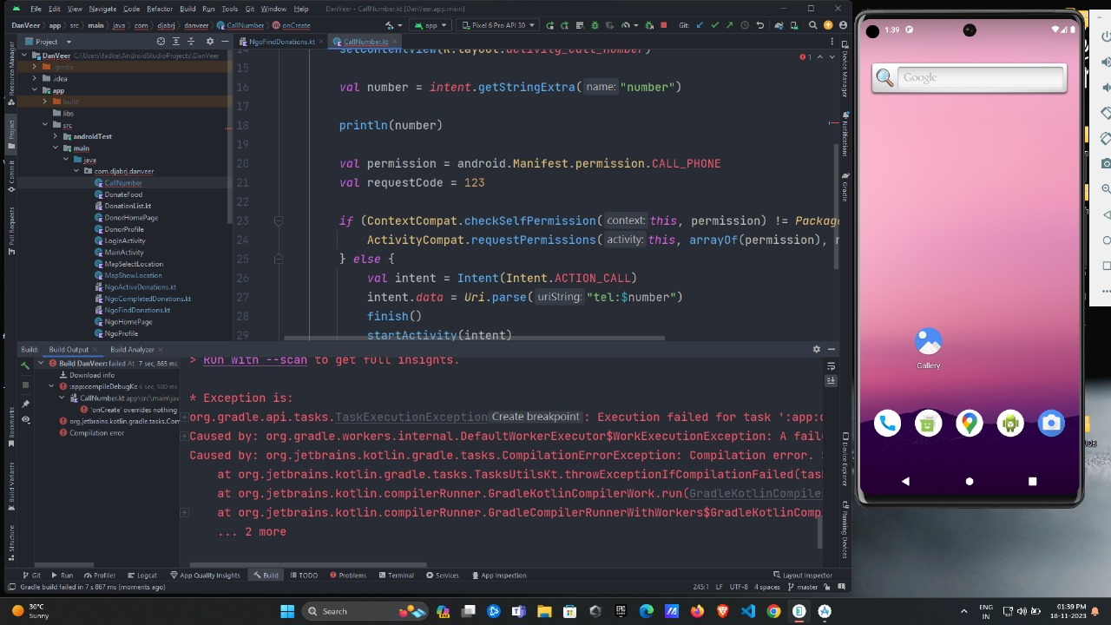

Resolving syntax errors in Android Studio involves identifying and fixing issues in your code. Here are general steps to help you address syntax errors:

* Read the Error Message:Look at the error message displayed in the console or the red underlines in your code. The error message often provides information about the issue and the location in your code.
* Understand the Error:Try to understand the error message and what it is indicating. It might be a missing semicolon, a misplaced parenthesis, a typo, or any other syntax-related problem.
* Navigate to the Error Location:Click on the error message or the red underlined code to navigate directly to the location of the error in your code. Android Studio will often highlight the problematic line.
* Review the Code:Inspect the code around the highlighted area. Check for typos, missing or extra punctuation marks, incorrect variable names, or any other syntax-related issues.
* Use Code Assistance:Take advantage of Android Studio's code assistance features. Autocomplete and suggestions can help you avoid common syntax errors. Pressing "Ctrl + Space" can trigger code completion.
* Consult Documentation:Refer to the official documentation for the programming language you are using (e.g., Java, Kotlin) to ensure that you are using the correct syntax for the elements in question.
* Check Imports:Ensure that you have imported the necessary libraries or packages. Missing imports can lead to syntax errors.
* Clean and Rebuild:Sometimes, the build process might not catch all errors. Try cleaning and rebuilding your project to force a fresh compilation. You can do this from the "Build" menu in Android Studio.
* Use Version Control:If you are using version control (e.g., Git), check if the issue is introduced in the latest changes. You can use version control tools to revert to a known working state.
* Search Online:If you're unable to identify or fix the issue, consider searching online forums, community websites, or the official documentation for help. Someone else may have encountered a similar problem.
* Consult the Community:If you're still stuck, consider seeking help on forums like Stack Overflow. Provide details about the error, relevant code snippets, and any troubleshooting steps you've taken.
* Check for IDE Updates:Ensure that you are using the latest version of Android Studio. Updates often include bug fixes and improvements that could address syntax-related issues

Dynamic Testing

1) UI/UX Issues

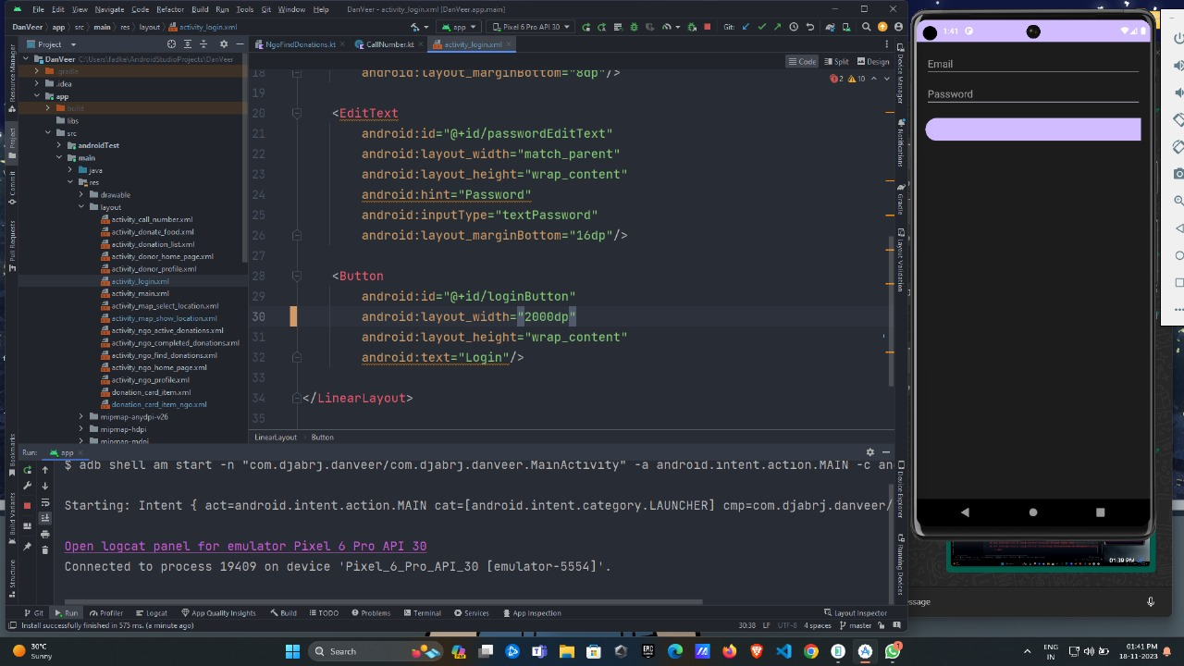

if the login button width extends beyond the screen boundaries, it's likely a layout-related issue and not a syntax error. This type of issue falls under the category of "Layout Errors" or "UI/UX Issues" rather than a syntax error.

Here are some common causes and solutions for a login button width extending beyond the screen:

* Layout Parameters:Check the layout parameters of the button in your XML layout file (assuming you're using Android XML layouts). Ensure that the width is set to wrap_content or a specific dimension that doesn't exceed the screen width.

Xml Copy code

<Button

android:layout_width="wrap_content"

android:layout_height="wrap_content"

<!-- other attributes -->

/>

* Parent Layout Constraints:Examine the parent layout of the button. If it's a RelativeLayout or LinearLayout, make sure that the width is set appropriately, and any constraints or weights are configured correctly.
* Screen Size and Density:Consider different screen sizes and densities. If the issue occurs on specific devices, it might be related to different screen sizes or resolutions. Use layout weights, percentages, or different layout files for different screen sizes if necessary.
* Use of match_parent:Be cautious with the use of match_parent for the width. If the parent layout has fixed dimensions, using match_parent for the button might cause it to extend beyond the screen.

Xml Copy code

<Button

android:layout_width="match_parent"

android:layout_height="wrap_content"

<!-- other attributes -->

/>

* Testing on Emulators/Devices:Test your layout on various emulators or physical devices with different screen sizes to ensure it behaves correctly on different platforms.
* Check for Dynamic Changes:If you're dynamically changing the width of the button in code, review the code responsible for these changes. Make sure it doesn't unintentionally set the width to an excessive value.

****Integration Testing****

1. **integrate Firebase services Error**

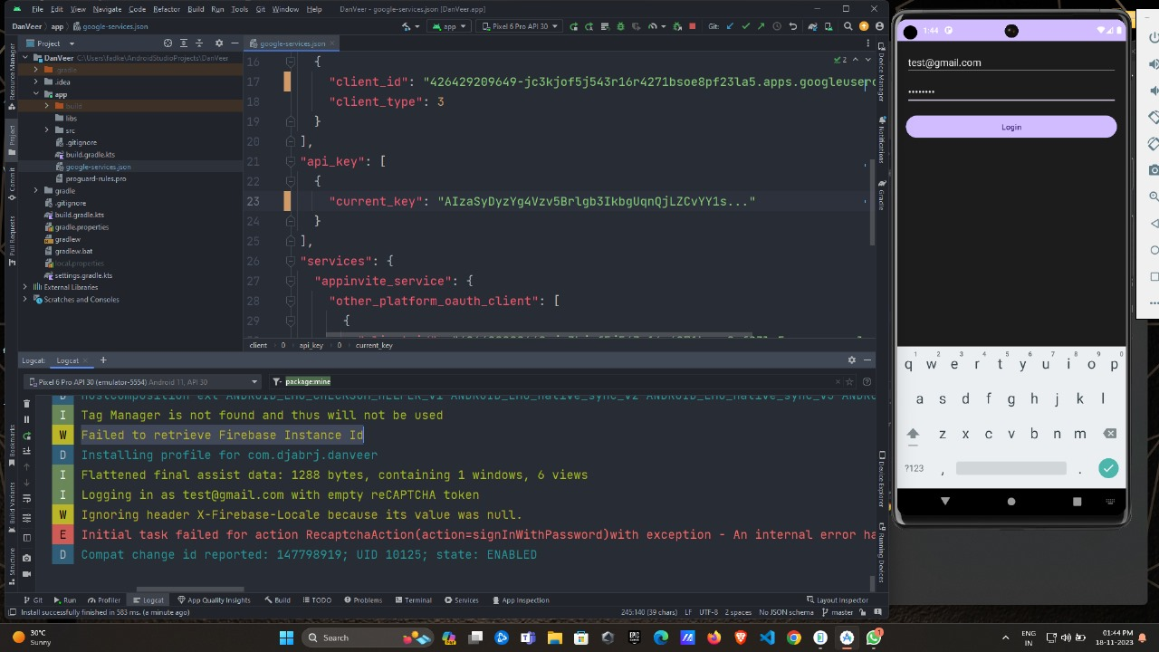

If you're encountering an error related to Firebase Instance ID and it says "failed to retrieve Firebase Instance ID," it could be due to various reasons. Here are steps to resolve this issue:

* Check Internet Connection:Ensure that the device or emulator you are using has a stable internet connection. Firebase services, including Instance ID, require an internet connection to work properly.
* Update Firebase Libraries:Make sure you are using the latest version of the Firebase SDK in your Android project. Check the Firebase documentation for the latest versions, and update your build.gradle files accordingly.

Gradle Copy code

// Example for Firebase Core and Cloud Messaging

implementation 'com.google.firebase:firebase-core:latest_version'

implementation 'com.google.firebase:firebase-messaging:latest_version'

* Check Firebase Project Configuration:Verify that your Firebase project is correctly configured. Make sure the package name specified in your Firebase project matches the package name in your Android project.
* Ensure Device/Emulator Has Play Services:Firebase services often rely on Google Play services. Make sure that the device or emulator has Google Play services installed and updated.
* Check Firebase Console for Issues:Go to the [Firebase Console](https://console.firebase.google.com/" \t "https://chat.openai.com/c/_new) and check if there are any issues or error messages related to your project.
* Verify Firebase Initialization:Ensure that you initialize Firebase in your application. This typically involves adding FirebaseApp.initializeApp(context) in your Application class or in the onCreate method of your main activity.

Java Copy code

// Example of Firebase initialization

FirebaseApp.initializeApp(this);

* Review Device Token Retrieval:If you are trying to retrieve the Firebase Instance ID token for Cloud Messaging, ensure that you are doing it correctly. Use the FirebaseInstanceId.getInstance().getInstanceId() method to get the token.

Java Copy code

FirebaseInstanceId.getInstance().getInstanceId()

.addOnCompleteListener(task -> {

if (task.isSuccessful() && task.getResult() != null) {

String token = task.getResult().getToken();

Log.d(TAG, "Firebase Instance ID Token: " + token);

} else {

Log.w(TAG, "Failed to retrieve Firebase Instance ID token.", task.getException());

}

});

* Check for Token Refresh:If the error is occurring during the app's lifecycle, make sure you handle token refresh correctly. Implement a FirebaseMessagingService and override the onNewToken method to receive refreshed tokens.

Java Copy code

public class MyFirebaseMessagingService extends FirebaseMessagingService {

@Override

public void onNewToken(String token) {

Log.d(TAG, "Refreshed token: " + token);

// Send the refreshed token to your server if needed

}

}

* Review Firebase Cloud Messaging (FCM) Configuration:If you are using Firebase Cloud Messaging, make sure your FCM configuration is correct. Check the google-services.json file and ensure it matches your Firebase project.
* Check for Firebase Dependencies Conflicts:Ensure that there are no conflicts between different versions of Firebase dependencies or other dependencies in your project. Use the ./gradlew app:dependencies command in the terminal to analyze dependencies.
* Review Proguard Rules:If you are using Proguard, make sure you have the necessary rules for Firebase. Firebase provides default Proguard rules that should be included in your Proguard configuration.
* Test on Different Devices/Emulators:Test your app on different devices and emulators to see if the issue is specific to a particular environment.